To receive a key or transponder to a Charité building/ office/ laboratory follow the steps below:
- Visit the following website from Charité Intranet: https://cfm-portal.charite.de/benefit/key
- Download the word-document “ Anforderung Schlüssel- und Transponder“
- Use word or a comparable program to edit the document
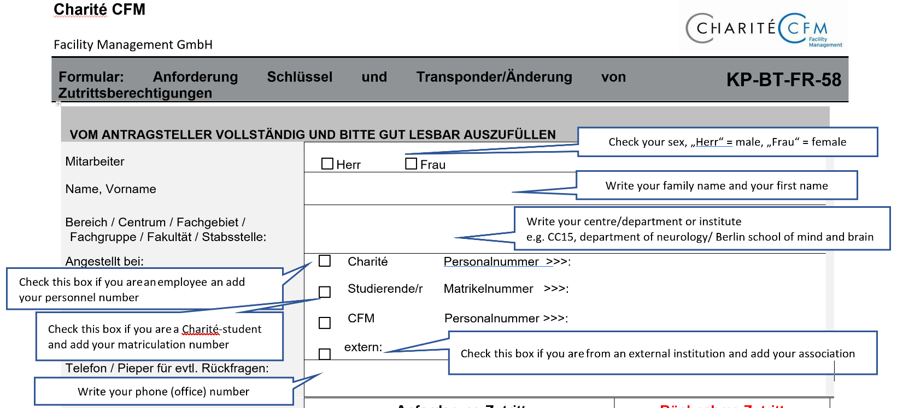
- Fill in your personal details as shown below:

- Fill in the details of the location or locations/room or rooms/ locker you need the key/ transponder for

- Sign the document

- Ask your supervisor to sign the document e.g. Carsten Finke or Christoph Ploner

- Ask your supervisor to stamp the document

- Ask your supervisor to add the time period you need the key for
To be filled in by your supervisor

- Check opening hours

- Bring your ID or passport
- Get your keys at the following addresses and follow the signs “Schlüsselverwaltung”
CVK
CCM

Important rooms:
For BCAN transponder: Sauerbruchweg 5 (Alte Chirurgie), Erdgeschoss, R 01.006

